1.Create a Custom class ‘Employee’ of the below defined structure
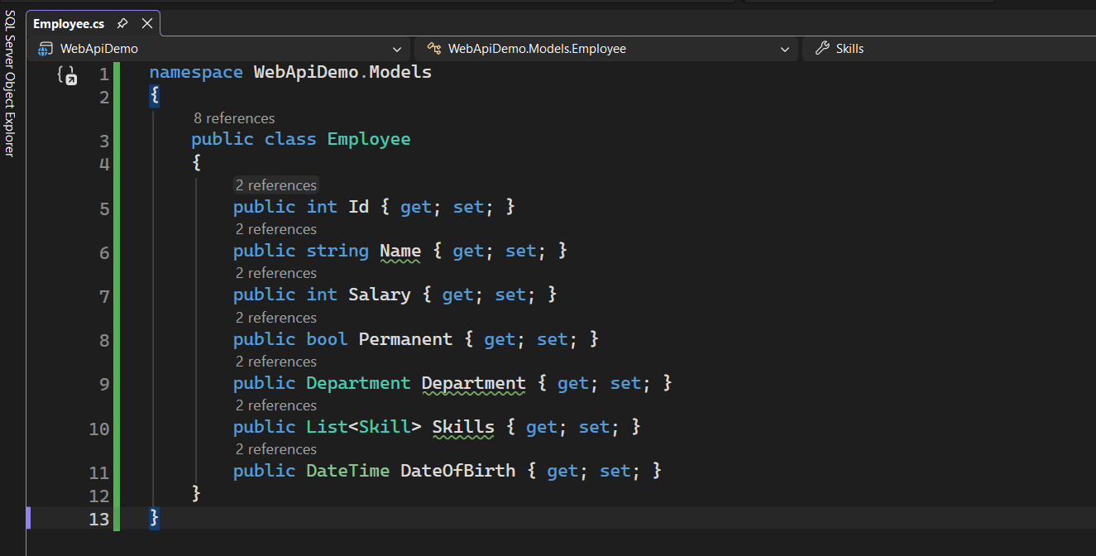

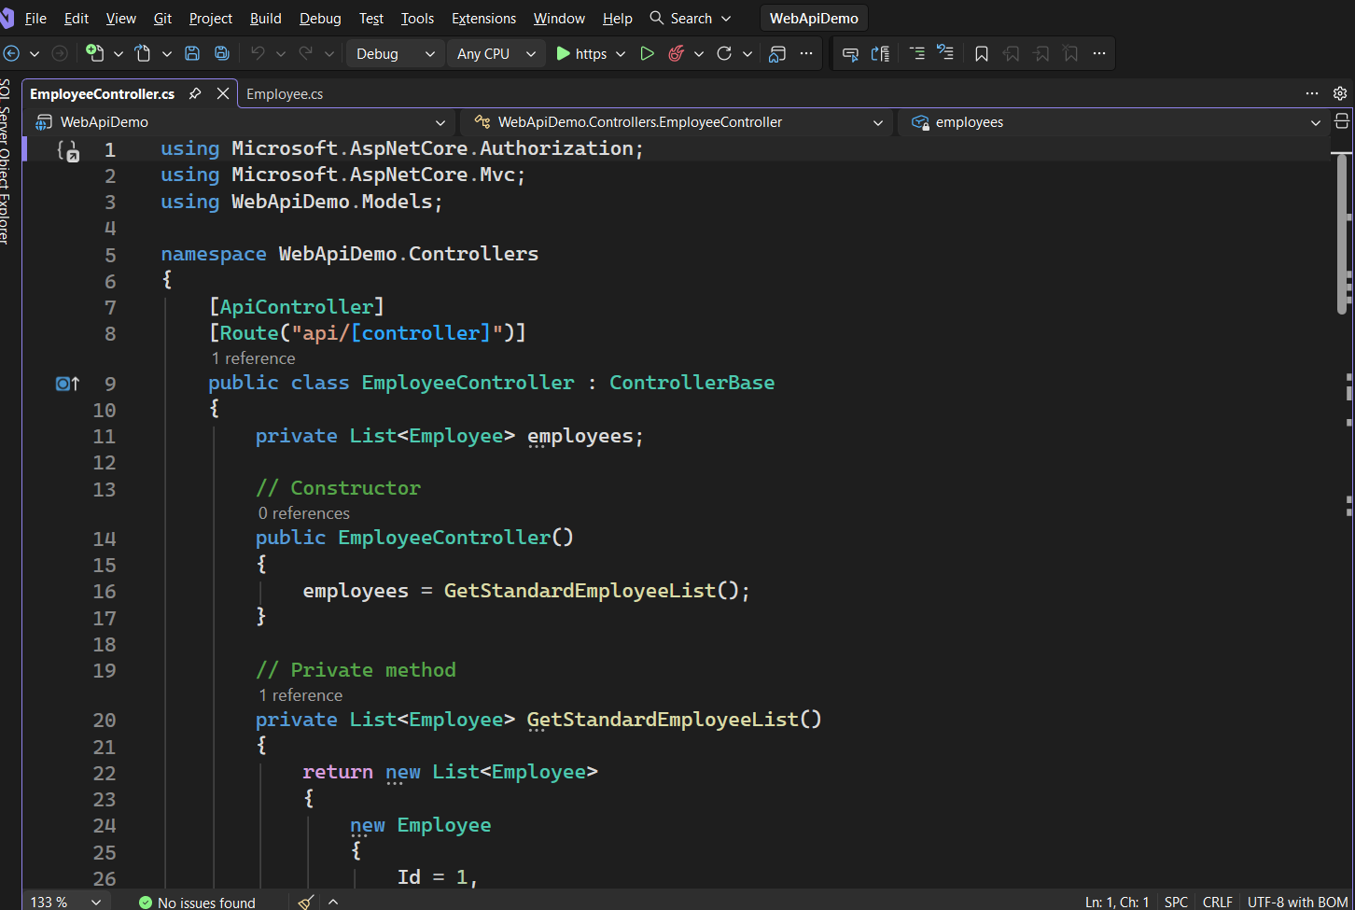
Create a new controller - EmployeeController with Read Write actions

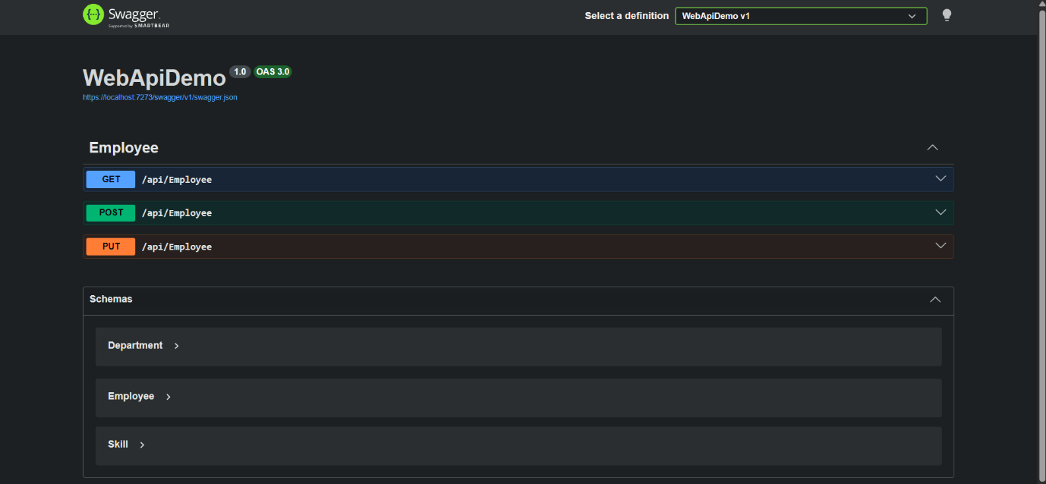
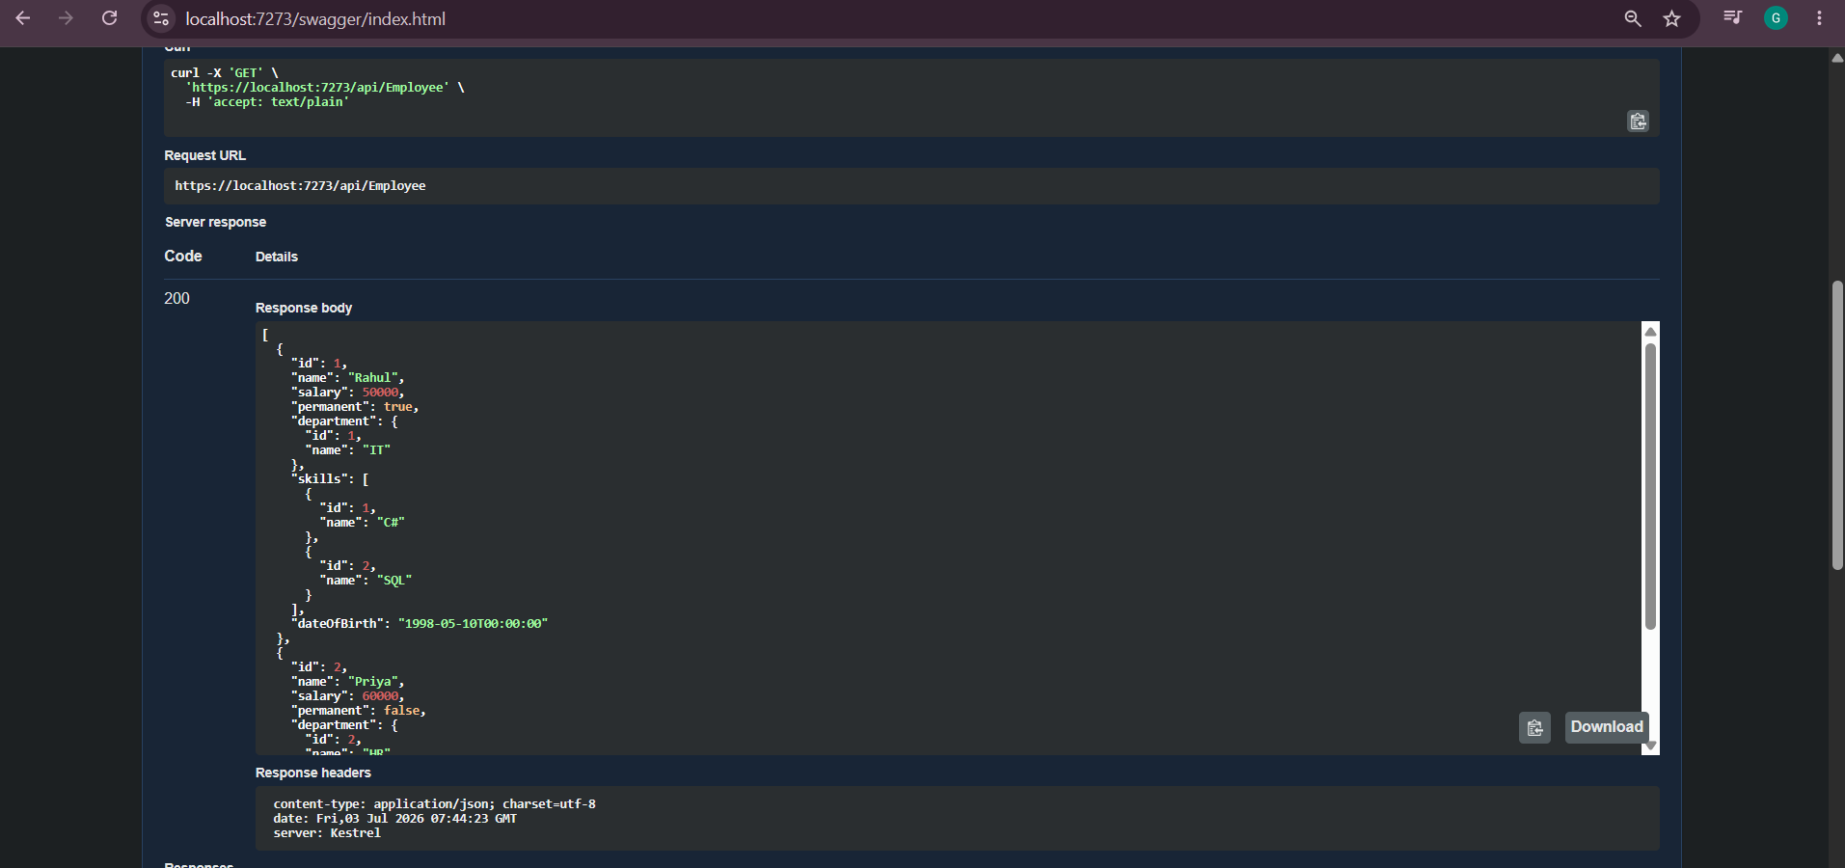

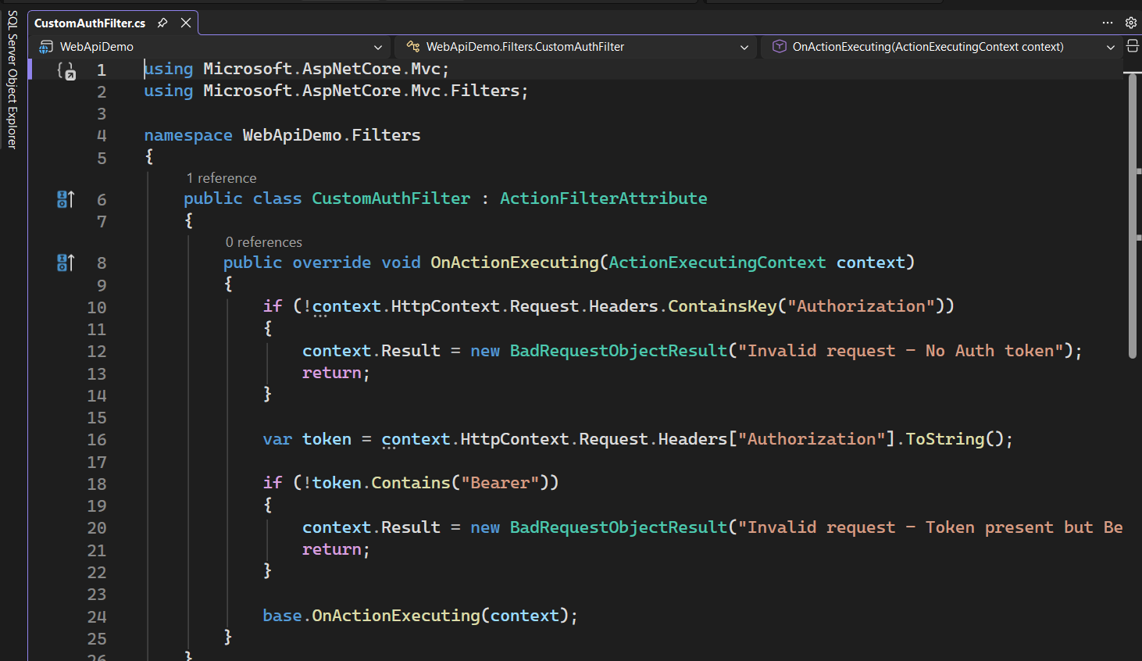
2.Create a Custom action filter for Authorization.

Invalid request - No Auth token
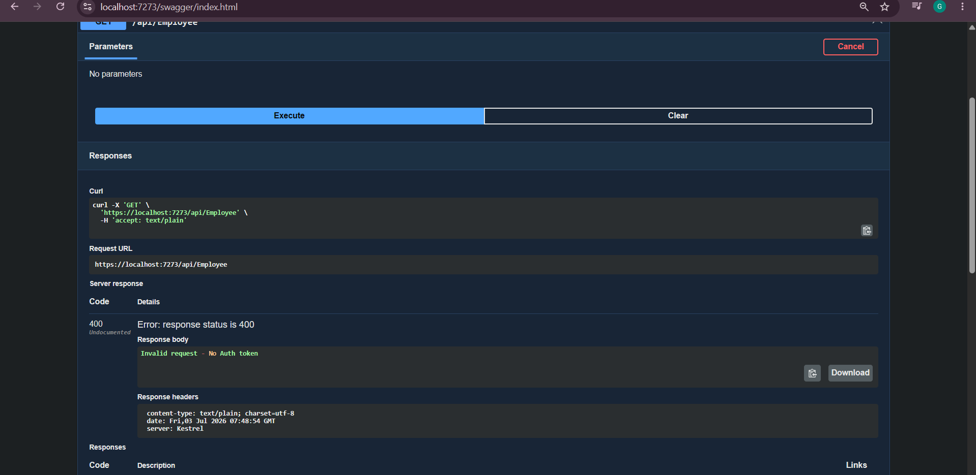

Add an attribute CustomAuthFilter to the Employee controller to filter any request to check for the Authorization token in the request header.

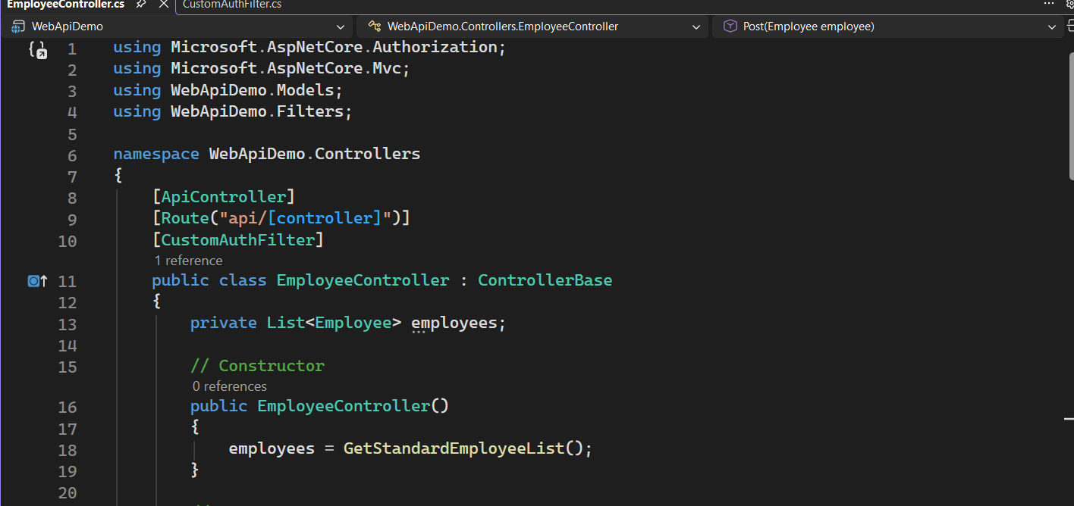

3. Custom Exception filter.
Use Swagger to test the exception and message being thrown.
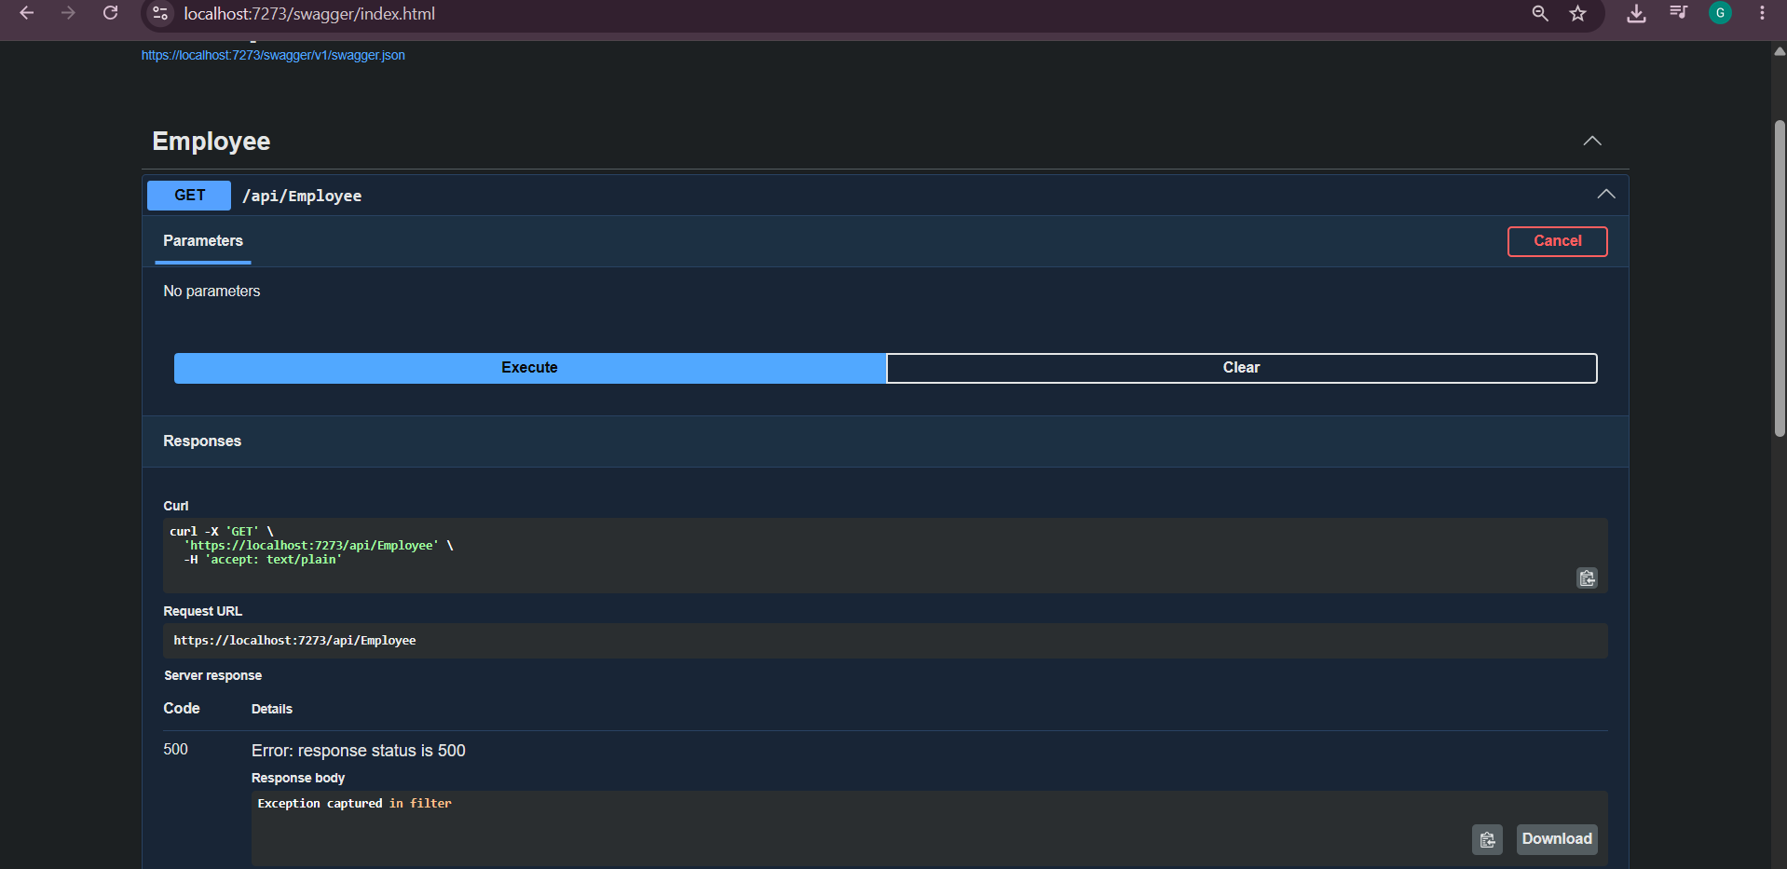

Postman testing of the GET
